**HISD INSTRUCTIONS ON LOCKDOWN BROWSER PROVIDED**

HISD’s IT team was able to add the **HCC Respondus LAB 2.0.6.08** to the HISD Software Center. It should work with the current version of the lockdown browser being used by HCC personnel. Please note that it may take upwards to 24 hours for this item to appear in the software center of a student’s PowerUp laptop.

The following instructions can be shared with remote testers to access the software center: <https://www.houstonisd.org/Page/183983>

**Attention Dual Students:**

If you need to install the HCC Respondus Lockdown browser on your HISD-issued laptop, please download the software from HISD Software Center. 

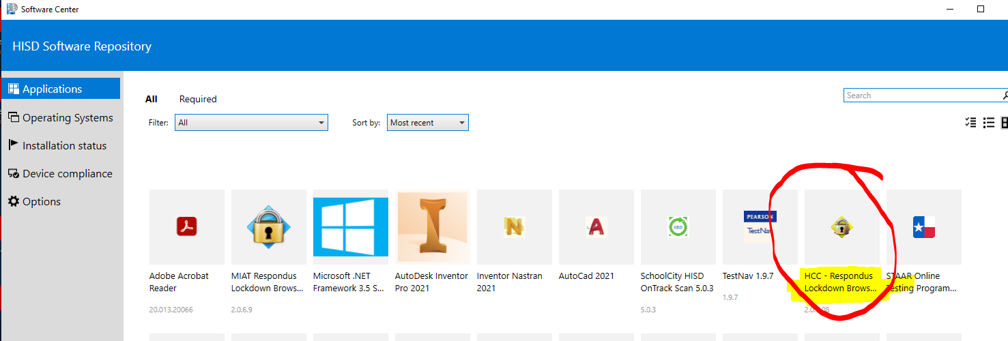

**PLEASE NOTE:** You **CANNOT** download the Lockdown browser from CANVAS or the HCC website. You must download the software from the **HISD Software Center**.